Porsche Club of America
Central Pennsylvania Region

Driving Tour Planning and Execution

This document is intended to provide a framework for planning and executing driving tours in a consistent and safe manner for the enjoyment of the participants. Additionally, tour planning is simplified by following a proven framework/process to ensure a successful event.

Driving Tour - Planning

Theme:
- Plan a tour around a central idea - Lunch destination, scenic destination, covered bridges, ice cream
spot, mountain roads, etc.

Region Location:
- Plan a tour in various areas of Central Pennsylvania to expand driver participation

Date/Time:
- Plan a tour with adequate lead time to generate interest
- Pick a Date and time for a tour taking into account the CPA region calendar

Duration/Distance:
- A tour can be a couple hours to a few days. This document is focused on a single day event
- Drive times greater than 90 minutes to 2 hours should consider a rest stop with bathroom facilities,
snacks and beverages

Start/Staging Location:
- Pick a location with adequate parking for the number of cars participating
- Location should have bathrooms, snacks and beverages
- Contact the start location for permission

Destination:
- Ensure the destination has adequate parking to accommodate the number of cars participating
- If there is a group activity at the destination make the necessary arrangements to accommodate the
group

Tour Planning Task Timeline:
- Manage a list of required tasks and timing to ensure the successful execution of a tour
- A Gantt chart is a useful tool to stay abreast of upcoming tasks

Driving Tour - Route Mapping

General Considerations:
- Plan a tour with roads and a destination that will generate interest and participation
- Select interesting roads that allow a continuous flow with a group of cars where possible
- Avoid intersections with poor visibility, congestion or other potential hazards that separate
the group. Right turns are often best but not always possible
- Consider points to regroup after congested/busy areas

Mapping Tools:
- Developing a route is simplified using available mapping software applications:
Google maps, Scenic, Apple Maps, MapQuest and Waze to name a few
- Using Google maps, street view provides a driver’s perspective of intersections or other areas of
concern to fine tune routing decisions
- Mapping tools like Google maps supports measuring the distance on each leg of a route for transfer to
hardcopy route navigation

Route Navigation:
- Once the route is created, drive the route to identify potential hazards, construction or other areas of
concern
- Define the starting point where to zero out the cars odometer. Notate the length of each leg of the route
and the total miles at the end of each leg
- Record stop signs, traffic lights and turn directions and note the road names, route numbers, etc.
- Adjust the route as necessary to avoid issues encountered on the drive
- Highlight any areas of particular interest on the route

Hardcopy Route Navigation:
- Select one of the available route navigation templates to document turn by turn directions or create
your own. Go to the CPA-PCA website. Tap on “Directory” under the CPA-PCA heading and navigate
to “Driving Tour Documents”
- Document areas where extra caution is required or areas of particular scenic interest
- If known beforehand, it is helpful to document the names and cell numbers of the people designated as
group leads or group sweep in the event there is a need to contact these people during the tour

Communication - General

Tour Announcement:
- Write an article to generate interest in the driving tour
- Allow adequate lead time ( 4 - 6 weeks) for inclusion in the CPA Region newsletter (Der Sprecher), post
to the region website and Facebook

Tour participant signup:
- Maintain a sign-up sheet as attendees RSVP their participation
- Contact information is critical for targeted communications pertaining to the tour in the event of
changes or cancellation due to weather
- The information collected is personal and should be managed respectfully

Here is an example of a driving tour sign-up sheet. Go to the CPA-PCA website. Tap on “Directory” under
the cpa-pca heading and navigate to “Driving Tour Documents”

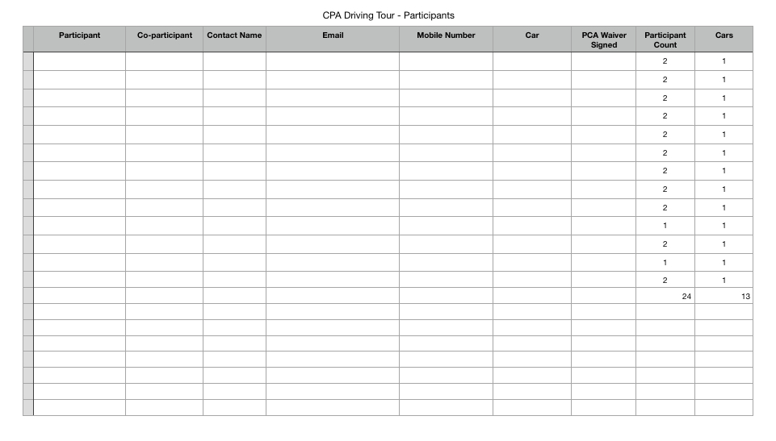

Driving Tour - Tour day Preparations

Insurance:
- All CPA tours require insurance
- Advise the CPA-PCA Safety Chair so the appropriate driving tour insurance can be
authorized
  - Information required for the driving tour
    - Event Type: Driving Tour
    - Starting location and ending location
    - Tour distance
- Allow 4 weeks to secure insurance

Participant Communications:
- Send an email reminder communication to all tour participants a few days in advance (use the bcc
option)
- Email should include:
- Tour Name, tour date, departure location name/address, assembly time, driver’s meeting time
- Special parking information and any special instructions regarding the tour
- Include a reminder that they must sign the Insurance Waiver Form to participate
- Attach a document with the tour driving guidelines that will be reviewed at the driver’s meeting
- Request participants wear their cpa-pca name tags
- Tour Cancellation - In the event of bad weather or other severe circumstances, contact all participants
via email (Email acknowledgement confirmation requested) or phone call confirmation so no
participants are missed

Material Preparation:
- Prepare talking points for Driver’s Meeting (essentially, highlighting the driving guidelines)
- Print in color the Release and Waiver Form to cover the number of participants (form located at the
PCA.ORG website)
- If minors are participating, print the Waiver for Minors Form, 1 form per minor (located on PCA.ORG)
- Print final RSVP List
- Print driving tour turn-by-turn directions

Two-way Radios:
- CPA-PCA owns 4 two-way radios for use on club driving tours
- The radios are very useful for the driving tour lead’s navigator to stay in touch with the group’s sweep
navigator for issues r keeping a group together
- The radios will be in the possession of the last driving tour organizer, or, they will be able to provide you
with the current location
- Remember: PENNSYLVANIA STATE LAW PROHIBITS DRIVERS TO USE A HANDHELD DEVICE

Driving Tour - Execution

Day of driving tour:
- Arrive at the departure location early to coordinate participants as they arrive
- As participants arrive, request they read and sign the PCA liability waiver sheet
- Reiterate to the participants the time of the driver’s meeting prior to departure

Driver’s Meeting:
- Lead a driver’s meeting prior to departing on the driving tour
- Ensure that all participants have signed the PCA liability waiver
- Highlight the key points in the driving tour guidelines you emailed to the participants
- If the group is large and necessitates multiple groups, separate the group based on preference for
“driving focus” or more “leisurely, scenery focus”
- Obtain the region’s portable PA system for use on the tour drive if necessary

Driving Tour - Review

Insurance - Post-tour document:
- PCA requires the submission of post-tour summary documents to be completed online at: pca.org
Search on the PCA website by form name or from the home page scroll down to “Commonly Used
Links” to find the reports

Post Event Report: Completed by the driving tour organizer
Event Observer Report: Completed by a participant on the driving tour
Incident Report: In the event of an unfortunate incident, this report must be completed

- Each report is automatically sent to the National Safety Chair, Region President and Region Safety
Chair
- Driving Tour Organizer should keep a copy of the reports with the driving tour documents

Participant Feedback:
- Solicit email feedback from participants for both the positive aspects of the driving tour and
recommendations how the event might have improved their experience. Continuous improvement will
help us provide a better experience for all club members

CPA Writeup:
- Ideally, a successful driving tour should be published on the club website and in Der Sprecher. This
communication helps club member participation in future events and also serves to motivate potential
driving tour leaders to create an event of their own
- Event write-ups can be submitted to national PCA for inclusion in our national club publication,
Panorama magazine, in the “From the Regions” section

Driving Tour Resources:

Drive Mapping Software:
- Google Maps
  - Commonly used routing software that will get you from Point A to Point B efficiently
  - Not ideal for planning and saving a specific, detailed route when you want to include specific roads
of interest
  - Executing a route, even when specific roads are included, Google will sometimes dynamically alter
routes based on current information
  - Street View feature is a nice feature to inspect intersections for potential sightline issues or other
safety concerns during route planning

- Scenic Motorcycle Navigation
  - Very simple and intuitive application for planning driving tours
  - Easy to export .gpx files and share with other members
  - There are costs to access all of the features in the application

Route turn-by-turn Navigation:
- Access templates for turn-by-turn navigation directions on the CPA-PCA website under the “Directory”
link
- Download one of these templates or roll your own

Participant Signup and Contact Information:
- Access a template for participant signup on the CPA-PCA website under the “Directory” link
- Download one of these templates or. roll your own

Driver Meeting Guidelines:
- This document contains important information pertaining to driving and general rules for participants
- These rules improve safety and allow a group of participates to work together and be courteous drivers

Tour Planning General Task Framework/Timeline:
- TBD

